Understanding Repository - 01

Eurico Costa

CIT-360 W16

# Java Collections

I’ve been learning about java collections in the context of my personal android app, which is going to be the app I presented in my pitch (<https://youtu.be/Al3K-SHBg_0)>, which is an app that will be used to report and find missing persons as a result of natural disasters. When the application is loaded, it will load to the screen a collection of records of missing persons, either that I am tracking, or that have recently had some sort of activity in the application, such as a new entry, or a record that received some sort of update.

## Research

A collection is an object that groups multiple elements into a single unit. Collections are used to store, retrieve, manipulate, and communicate aggregate data. They represent data items that form a natural group, such as a collection of cards in a flash card study app, an email folder (a collection of emails), or a list of missing person records (as in the example of the app I am working on).

Java implements a Java Collections Framework that standardizes the way in which groups of objects are handled by programs. Collections were added in Java release J2SE, 1.2. This implementation was an improvement on the previous versions of what were the previous implementations of what could be called collections: Dictionary, Vector, Stack, Properties.

The modern collections framework is a highly optimized and high-performance implementation that shares a common framework that allows dynamic arrays, collections of different types of objects, and collection types that are also extensible. The list below is just a fraction of all the types of collections supported by the framework, and only reflects the most commonly used:

* ArrayList
* Dictionary
* LinkedList
* Properties
* TreeMap
* Vector
* Deque
* Enumeration
* List
* Map
* NavigableMap
* Queue
* Set
* SortedSet/SortedMap

In the first meeting we had as a team this semester, my colleague, Clinton, presented on the subject of Java collections. I was intrigued with something he mentioned in his presentation regarding regarding the List interface and how it allowed duplicates of objects in the list, and created the code below, with accompanying post to clarify the issue and confirm that, indeed, it allowed duplicates:

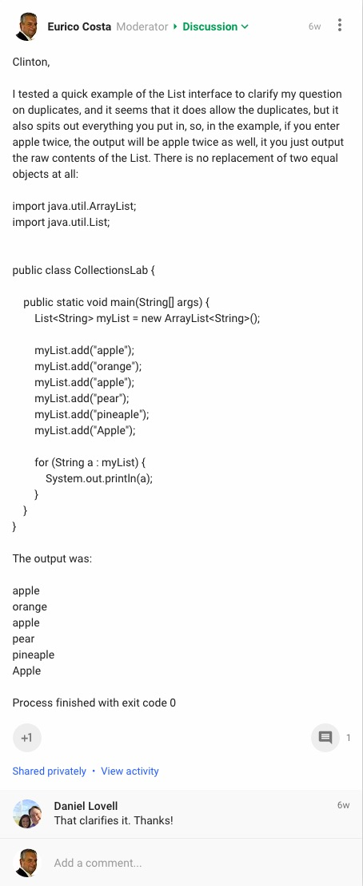

# Use Case Diagrams

As part of my contribution to the group application, I’ve worked on the Use Case diagram of the use cases to be implemented in the application.

A UML Use Case diagram describes a set of actions (use cases) that the system should perform, triggered by the users of the system. The link below leads to the Use Case diagram I created:

<https://github.com/Costa-Eurico/CIT-360-W16-Understanding-Portfolio/blob/master/Understanding%20Portfolio%20Submission%2001/Flash%20Card%20Application%20-%20Use%20Case%20Model.png>

I presented on the Use Case diagram in the team presentation, that can be found here:

<https://youtu.be/ljViA9TU0SU?t=4110>

My intervention starts at time frame – 1:08:38. The link above should start playing the video a couple of seconds before my Use Case slide comes up.